MgSafe
GA, Boards meeting and Materials Workshop
Warsaw, Poland, 14-18 June 2021
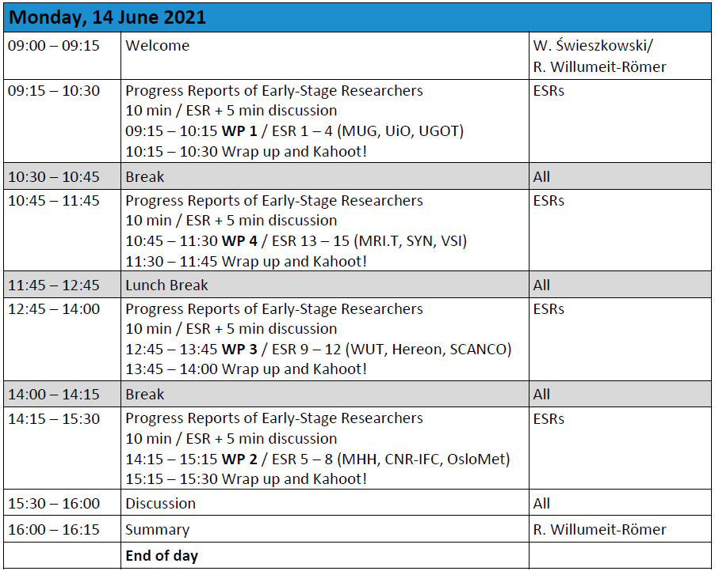
Agenda
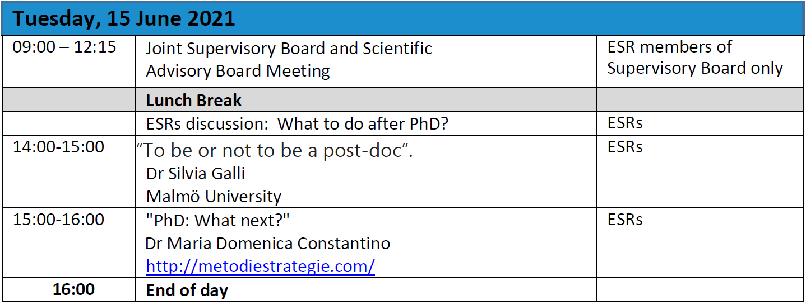

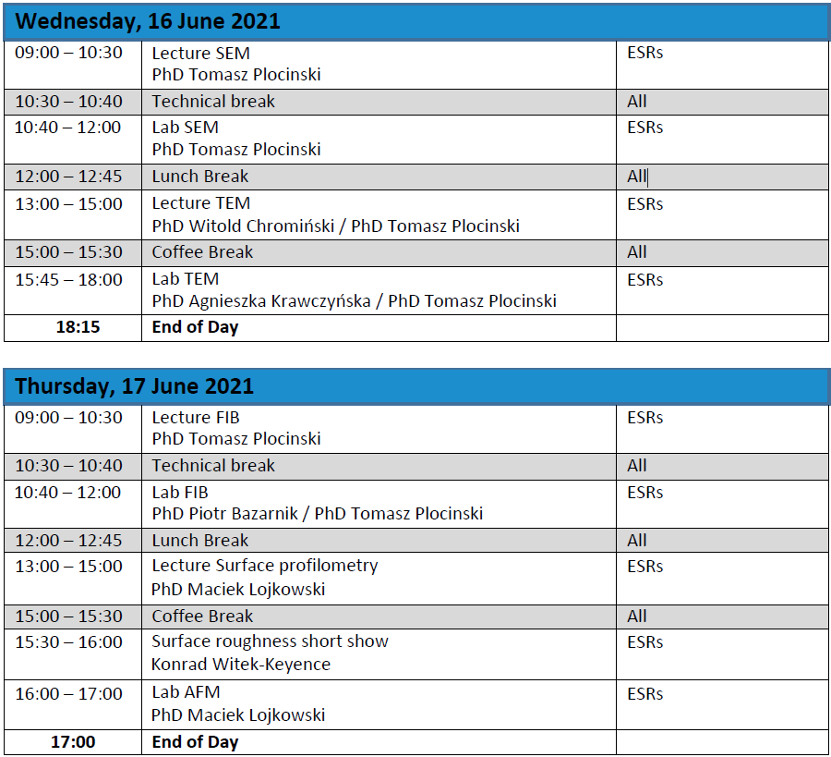
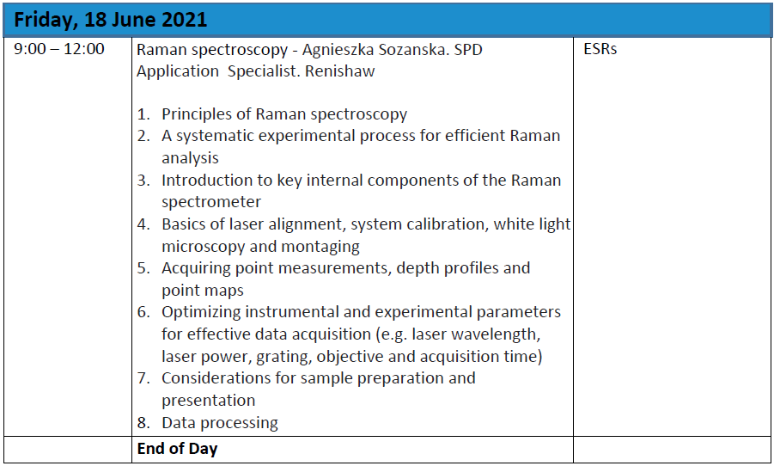

Abbreviations:
SB - Supervisory Board
SAB - Scientific Advisory Board
ESR - Early Stage Researcher, PhD student
WP - work package
SEM - scanning electron microscopy
TEM - transmission electron microscopy
FIB - focused ion beam scanning electron microscopy

Consortium Members:
Hereon - Helmholtz-Zentrum Hereon, Germany
CNR-IFC -Consiglio Nazionale delle Ricerche, Italy
MUG -Medizinische Universität Graz, AustriaUiO -Universitetet i Oslo, Norway
OsloMet - Oslo Metropolitan University, Norway
MHH -Medizinische Hochschule Hannover, Germany
UGOT -Sahlgrenska Academy at University of Gothenburg, Sweden
WUT -Warsaw University of Technology - Politechnika Warszawski, Poland MRI.T -MRITools GmbH, Germany
SYN -Syntellix AG, Germany
SCANCO - Scanco Medical AG, Switzerland
VSI -FujiFilm Sonosite B.V, The Netherlands
Partner Organisation:
BRI.T - BRI.Tech – BioResorbable Implant Technologies, Austria

